

|  |  |  |
| --- | --- | --- |
|  | **Model Development Phase Template** | |
|  |  |  |
| **Date** |  | **5th July 2024** |
|  |  |  |
| **Team ID** |  | **739687** |
|  |  |  |
| **Project Title** |  | **SMS SPAM DETECTION** |
|  |  |  |
| **Maximum Marks** |  | **4 Marks** |
|  |  |  |

**Initial Model Training Code, Model Validation and Evaluation Report**

**The initial model training code will be showcased in the future through a screenshot. The model validation and evaluation report will include classification reports, accuracy, and confusion matrices for multiple models, presented through respective screenshots.**

**Initial Model Training Code:**

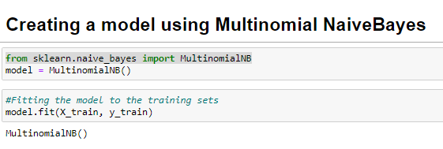

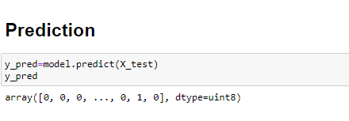



**Model Validation and Evaluation Report:**

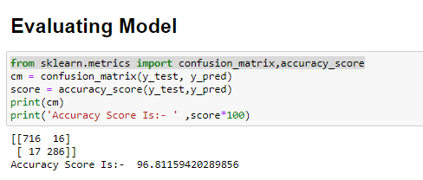

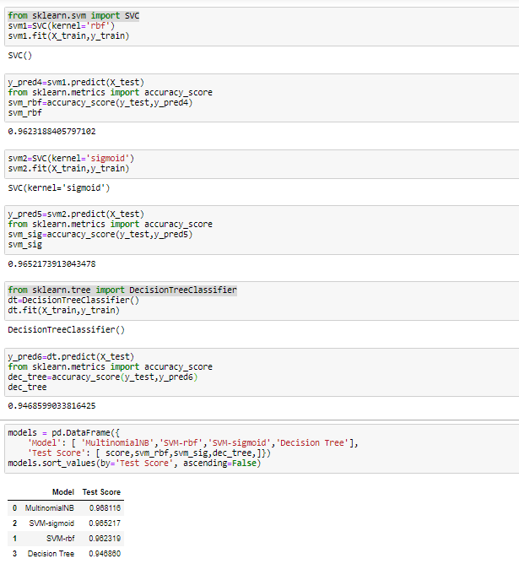

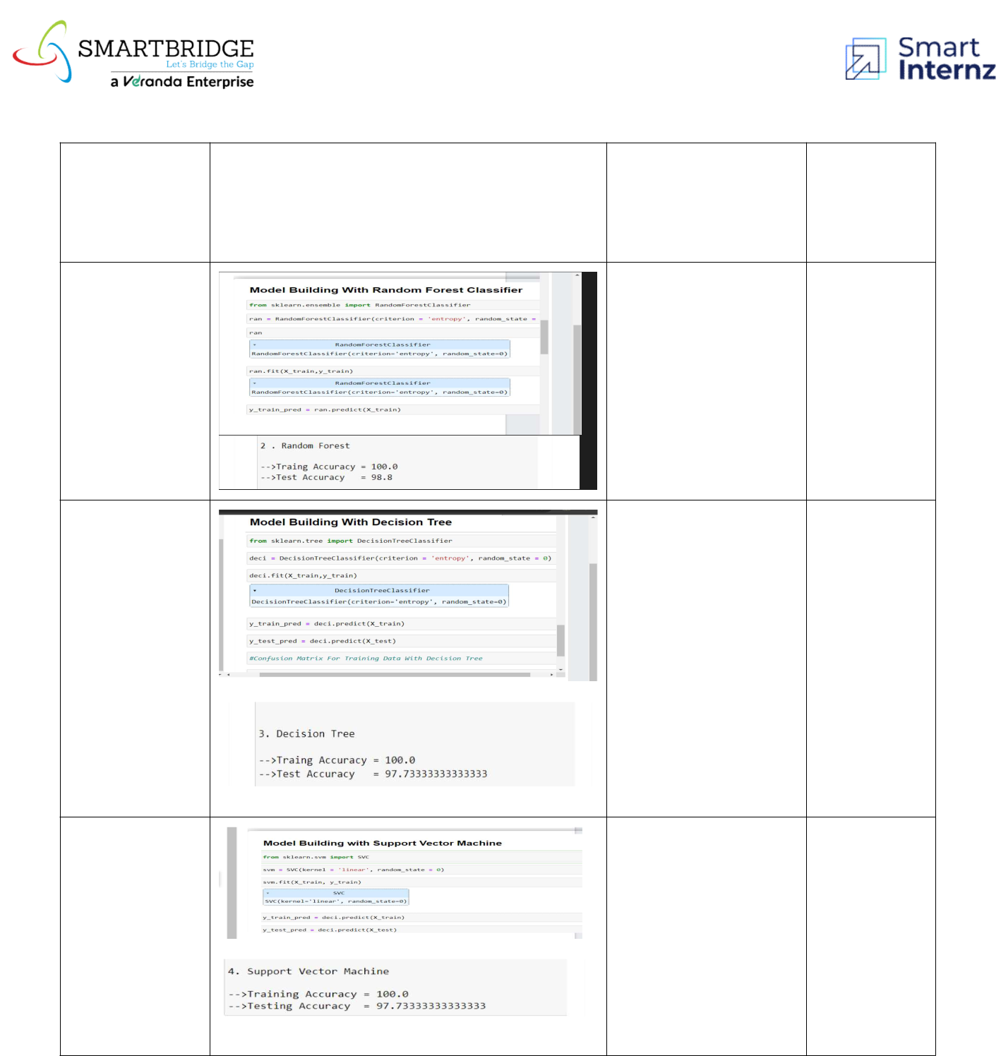

|  |  |  |  |
| --- | --- | --- | --- |
|  |  |  | **Confusion** |
| **Model** | **Classification Report** | **Accuracy** | **Matrix** |

|  |  |  |  |
| --- | --- | --- | --- |
| **Random** |  |  |  |
| **Forest** | **98%** | **-** |  |
|  |  |  |
| **Regresso** |  |  |  |

|  |  |  |  |
| --- | --- | --- | --- |
| **Decision** |  |  |  |
| **Tree** | **97%** | **-** |  |
|  |  |  |
| **Regressor** |  |  |  |

|  |  |  |  |
| --- | --- | --- | --- |
| **Gradient** |  |  |  |
| **Boosting** | **97%** | **-** |  |
|  |  |  |
| **Regressor** |  |  |  |